10th Annual PHINS Gumbo Festival
March 24, 2015 By Millie Marie Taylor
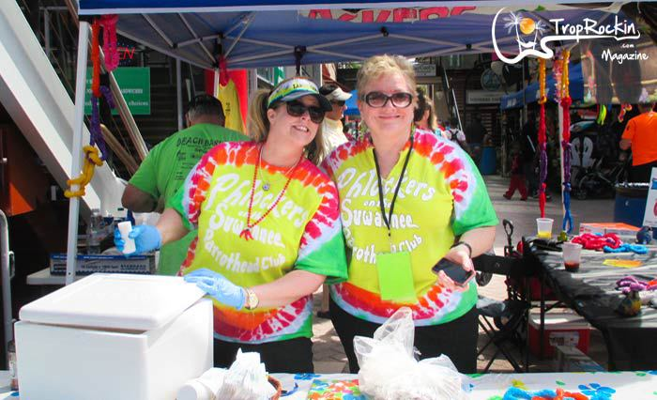Gumbo booth”Pots of Gold” by Phlockers on the Suwannee Parrot Head Club. People’s Choice 3rd Place!

10th Annual PHINS Gumbo Festival
“ Fighting Hunger One Bowl At A Time”
Story & Photos by Millie Marie Taylor
Check out more of the fun photos in the gallery: PHINS Gumbo Fest Photo Gallery 2015
Friday Night Happy Hour
The Jacksonville Landing located in downtown Jacksonville on the St. John’s river turns into Parrot Head Square for the annual gumbo festival hosted by hosted by Parrot Heads In Natural Settings (PHINS). Ping pong football table, corn hole and little wood surf boards used to play the hook/hoop games during the social happy hour. Parrot Heads and locals welcoming everyone to Friday evening at the PHINS Gumbo Festival Happy Hour.
Friday night music from the Mango Margarita Band brought out line dancing in front of the stage and conga lines around the fountains. The Mango Margarita band is a musical creation between Dustin “Dusty” Barber and his Conch Fritter partner Barry “The Pan Man” Olsavsky blending with Shane Barber (drums) Tommy Gilstrap (bass) Mike Devereaux (percussion) John Kamanski (guitar). Each member brings great sound and character to fill a night of island beats to move your feet.
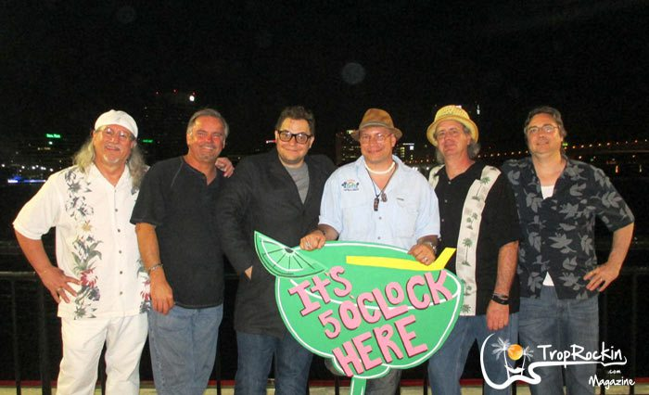Mango Margarita Band put the Happy in the PHINS Gumbo Fest Happy Hour.
Dusty and Barry are also in a trio, The Conch Fritters. One of the things I love is how they bring the music to the crowd. It is part of The Conch Fritters signature performance to play with the crowd, in the crowd and for the crowd for a high level of pure audience participation. You could see Dusty and Barry mingle with fans in the happy hour crowd.
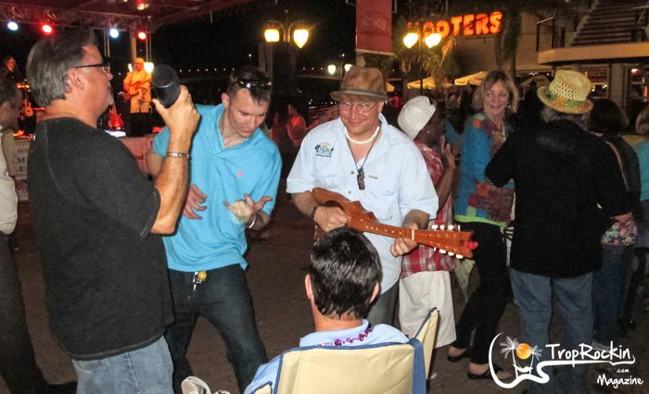
A tidbit about Dusty and Barry: Dusty is also lead guitar for The Al Green Orchestra and David Allen Coe. Barry is a solo artist performing at Bahama Breeze in Jacksonville, FL and also tours with Gary Roland and The Landsharks Band.
Saturday Gumbo Fest
Saturday brought out the big pots and large stirring paddles to start the gumbo battle.
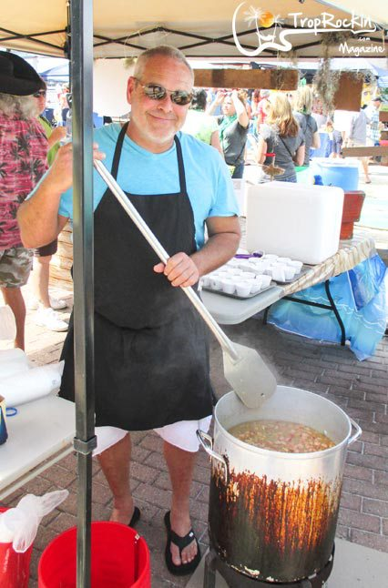Stirrin’ the Pirate Booty Gumbo
“DesdeMona’s Cousins & Illegitimate Children” had a recipe with lots of flare. “Pirate Booty Gumbo” had the treasure ingredients boilin’ up and “Breath in Breath out Gumbo” (Mandarin Food Bank) were stirring up some gumbo so good they had card board Jimmy Buffett first in line. “Nowhere to Rum” was selling merchandise and signing autographs while cookin’ the gumbo.
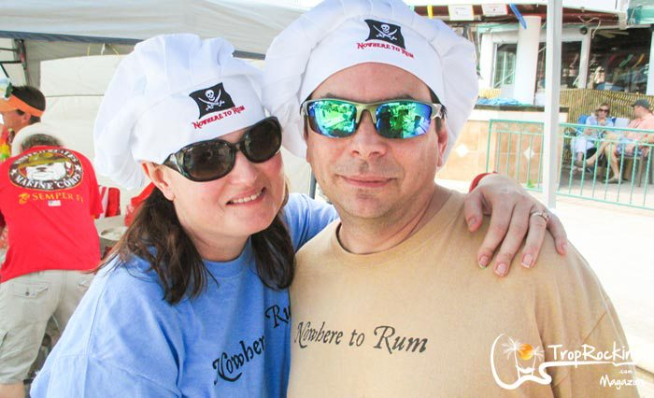Vernon & Rachel Densler, Trop Rock duo, cook it up with “Nowhere to Rum”
The Phlockers on the Suwannee Parrot Head Club had their bright attire on and shining smiles to help boast their “Pot Of Gold.” “Tidbits” had their crew all over the fest enjoying everything and the “FP & K” Chefs had a real seafood gumbo recipe caught up in their pot. “Cajun Sausage Soup” showed up to show us a great way to put it all together in a gumbo soup.
I am pretty sure American Electrical and Phlockers of the Suwannee had the parties going on. Popular booths with crowds standing around them for an hour before serving time were “Pots of Gumbo”, “WCR Jax”, “Gumbo Guys” and “American Electrical.”
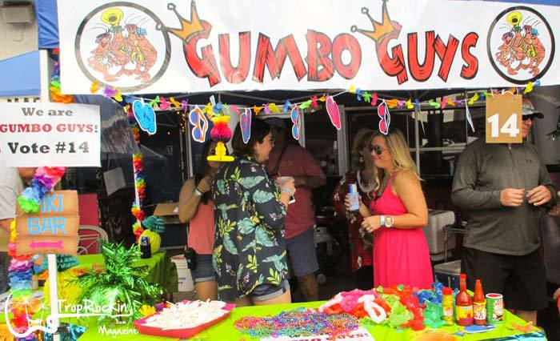
We even had a little sports fun going on with “Triple Threat Gumbo’s” Kittima Begier sporting her tough pink martini apron, “Gator Hut” showing She is a Seminole Fan while He wears His Gator Head shirt and “Lillian’s Sports Grill” is ready to rumble with their gumbo.
“Omni Jax” was hard to find while wearing their camo and cookin’ the gumbo. PHINS Gumbo Fest is about the gumbo, booth showmanship and pleasing the crowd.
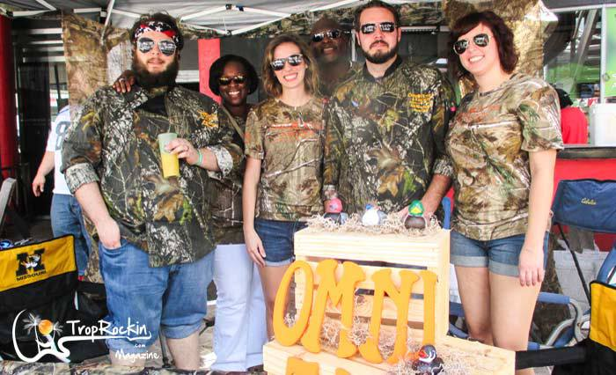Camo Gumbo from the Jacksonville Omni
All 16 competitors were working the crowd and I must say a few tried to work the Judges. Thanks to our great volunteers of security guys the Judges were not tainted.
George Aspinall Band Helps the Cooks Cook
The George Aspinall Band had the cooks stirring and the hungry crowd dancing for the gumbo. Cooks, Phlockers and children could not help but to sing along to that famous Jimmy Buffett song “I will play for Gumbo.” This year with the beautiful weather, smells and sounds the volunteers at the Gumbo Fest ticket line had their hands full with gumbo lovers. The excitement of tasting all that gumbo and getting to be a “People’s Choice” judge even had my own family tasting to score.
George Aspinall Band set the music tempo for this crowd. One Chef played air guitar on his stir paddle, another did little hip action stirring and a Pirate Chef nodded along as he tapped his feet. The Chef at the American Electrical booth took the cake by singin’, dancing the stir and toasting drinks to the crowd. How could anyone not want to spend a weekend at this event?
I am not sure what was put in all that gumbo to make folks so happy. I think all the Chefs added love and happiness to their pots.
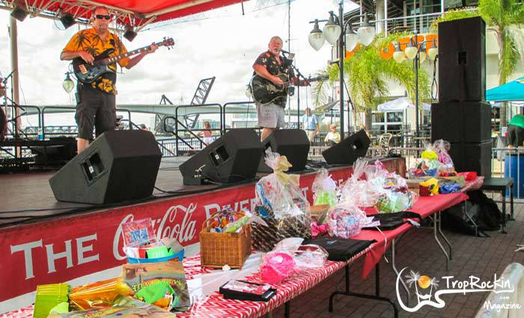George Aspinall Band keeps the cooks going in the afternoon. Check out that table of raffle baskets!
Finishing off with a Trop Rock Party!
What better way to end a Gumbo Fest? The River City Brewing Company, located right across the river from The Jacksonville Landing. Hop on the bridge or take a water taxi to enjoy a beautiful “free” sunset. On arrival we were greeted by the sounds of Don Middlebrook. The “Don of Trop Rock” did not disappoint these gumbo filled Phriends, he fed us more songs and stories to help start the conga line workout and the ladies were taking turns on stage to play with his shakers.
Don has a wonderful memory and uses it to for word play in his songs. The fun of watching Don welcome a crowd and then jump back on stage (after meeting 50 or so people) and adding your name or story to a song is a Parrot Head 7th wonder. Lesson to be learned around Don – He never forgets. So if you have a golden moment of too much wine, rum or other libations you just might hear your name in a song followed by laughter with a small “I remember that.”
He also wanted to help all the men out with drinking and getting to the point. So Don asked the men to stand in front of the stage and serenade the ladies – Well the ladies laughed as the guys joined Don in singing “Why don’t we get drunk and screw.” I have to admit the guys did a pretty good job. Before he left the stage he was so polite to introduce Todd Sparks. That is why Don is the wooing “Don of Trop Rock” and his flirtation self. Just call him Mr. Nice Guy.
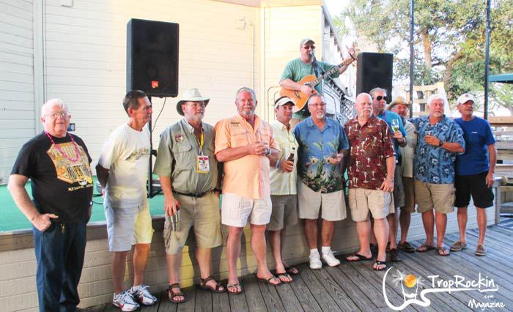Don Middlebrook trying to help the men get lucky.
Todd Sparks started up right where Don left us. Todd pulled out some old Buffett and what do Parrot Heads do when you play old JB songs??? Trivia and stories of where and what concert tour that was. The fun was in full song and laughter when a loud shout from the crowd yelled “Do you know any Todd Sparks’ songs?” Laughter filled the air and a grin from Todd as he said “I think I may know him – I could try.”
I have never heard folks shout such silly words before….. until Todd’s 4th toast “Wait slow down – You are drinking too fast.” Someone in the crowd had the come back before Todd could take a breath – “Is there a drinking speed limit?” There’s a new song in the making. Don’t know how well it would catch on since this was the first time I have ever heard any Phlock say slow down on drinking.
As the late night settles in, it’s time for those hugs and goodbyes as the Phlock starts to break apart. Spreading their wings and promising a return was The Villages. Soon after was the Phlockers of Suwannee spreading their wings and reminding us to see them in June. The faithful well doers were Parrot Heads In Natural Settings and a A1A Parrots holding up a toast to the “2016” Gumbo Fest.
Special Thanks to all the Volunteers – Vendors – PHINS – A1A PHC – Phlockers of the Suwannee PHC – The Villages PHC – Guests – Chefs – Judges.
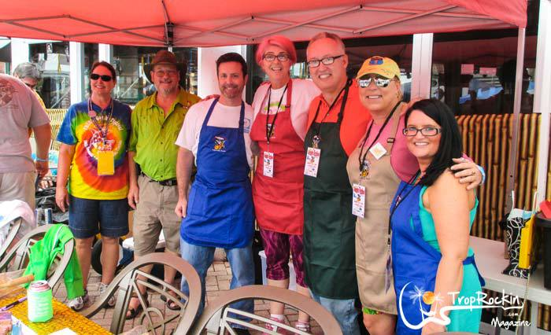Debbie and Jeff (PHINS Parrot Head Club) with the 5 gumbo tasting judges.
Congratulations Gumbo WINNERS:
-Judge’s Choice Restaurant Division: Tidbits (3rd year winners)
-Judge’s Choice Overall: Pirate Booty Gumbo (Nan & Mike Clark)
-People’s Choice 1st Place: Gumbo Guys (Charlie Lowe & team)
-People’s Choice 2nd Place: Omni Hotel Jacksonville
-People’s Choice 3rd Place: Pots of Gold – Phlockers on the Suwannee Parrot Head Club
-Showmanship: Omni Hotel Jacksonville with their Duck Dynasty theme
A message from PHINS Inc. Pres. Debbie Renfroe:
On behalf of the Parrot Heads in Natural Settings Parrot Head Club:
Thank you to those who joined us at the Gumbo Fest!
It was a good day for supporting our charity the Mandarin Food Bank, who was the fundraiser winner and in food collection.
Thank you to all those cooks who brought it to the Jacksonville Landing. The Gumbo Festival is nothing without your wonderful support!
CONGRATULATIONS TO ALL!
See everyone back next year for our 11th PHINS Gumbo Festival at the Jacksonville Landing.
Check out more of the fun photos in the gallery: PHINS Gumbo Fest Photo Gallery 2015
Click & Share with your friends. Thanks for spreading Trop Rockin'!
FacebookTwitter
Filed Under: Trop Rock Tagged With: Don Middlebrook, Parrot Heads, PHINS Gumbo Festival, The Conch Fritters, Todd Sparks, Trop Rock Events

About Millie Marie Taylor
I live close to A1A and love this stretch of road that leads me to so many adventures! I'm perfectly situated between my two wonderful children. I love to visit my daughter in the FL panhandle and my son in Key West. I'm a Parrot Head and I love Trop Rock music!

